FAST® XDi Sportsman™ Distributor For Ford 2.3L (2300) Engines Offers Power Increases Through Unmatched Ignition Stability

Memphis, TN – The new FAST® Ford 2.3L (2300) XDi Sportsman™ distributor outperforms the competition by using an advanced optical trigger for the most stable ignition timing throughout the entire RPM range.

The distributor is ideal for oval track racing or any other performance application. Its advanced optical trigger was designed in-house and delivers more precise trigger signals than magnetic pickups used by our competitors. This accuracy (+- ½ deg) eliminates the inaccuracies common at high RPM in the magnetic style. The FAST® Ford 2.3L (2300) XDi Sportsman™ distributor is constructed with a billet housing, a precision-ground stainless shaft and premium bearings, all hand-assembled to exacting standards. This maintains a consistent end play that eliminates another common source of timing fluctuation. These key features are why the FAST® XDi Sportsman™ distributor makes more horsepower than the competition.

Each distributor comes with a precision-machined bronze gear and must be used with an external ignition box, such as the FAST E6 CD Ignition.

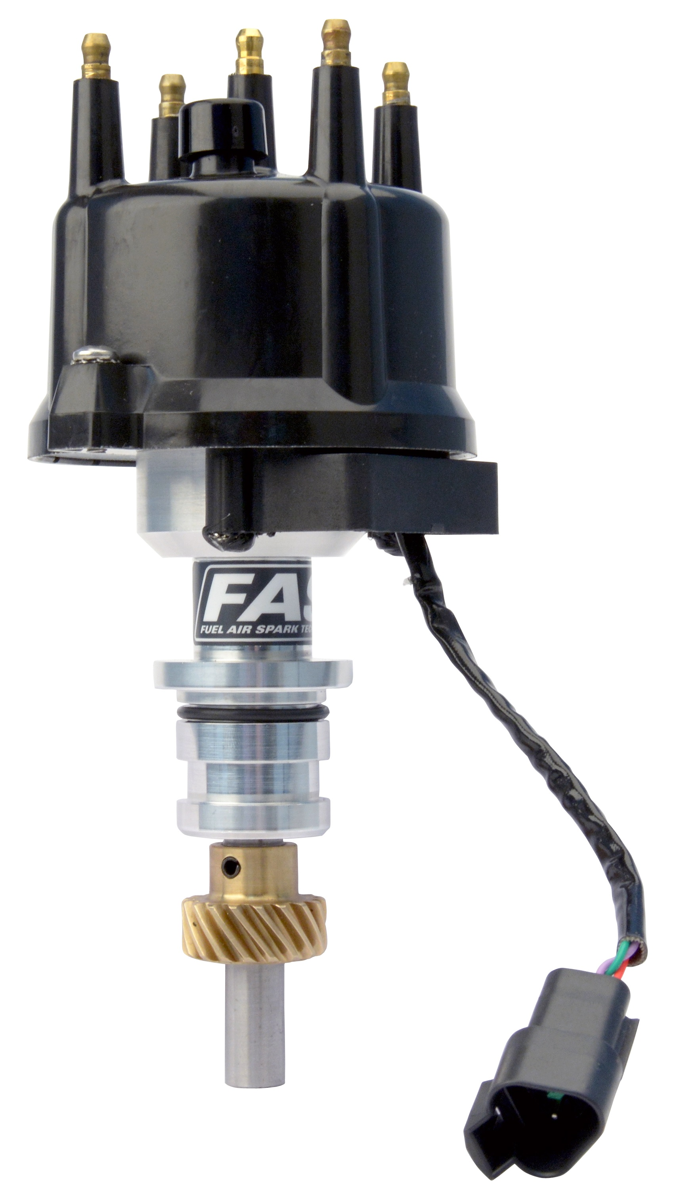

Quick Facts

Product: FAST® Ford 2.3L XDi Sportsman™ Distributor
Part Number: 1000-1625
Street Price: $321.76

Social Media Pitch: FAST® Ford 2.3L XDi Sportsman™ distributors offer superior ignition stability for more power that is perfect for oval track or high-performance use

Features & Benefits:
- In-house-designed, advanced optical pickup delivers accurate trigger signals at all RPM (+- ½ deg.)
- Precision billet construction & assembly maintains consistent end play for timing stability
- Compatible with most ignition boxes & comes with a precision-made bronze distributor gear

Media Contact: Cindy Bullion, cbullion@compcams.com, 901.795.2400 ext. 1643

